电化学原位Raman测试单
一、原位电化学Raman测试介绍

1 如果需要通气，气体蠕动模块有氮气、氩气、氧气；
2 组装原位池以后，如果客户终止测试的，需要客户承担500元工时费。（测试的特殊性，望理解）。

二、样品信息以及测试条件确认
- 样品材料成分、尺寸？Raman电解池可夹的电极片尺寸一般为10mm-25mm。
成分：基底为不锈钢纤维，活性物质为NiCo₂S₄@Fe₂O₃
尺寸：直径20mm，长度可随意控制
- 是否为单原子或者团簇的样品？
否
- 做哪种电催化体系

- 电压窗口范围，vs.Ag/AgCl
-1.0V至0.4V至-1.0V（再从0.4V返回去）
- 电催化体系参比电极和对电极分别是什么
参比电极：饱和干汞电极
对电极：铂片
- Raman扫描范围（扫描范围，建议扫主要峰的区域）
200 cm⁻¹----1000 cm⁻¹
- 激光器波长，目前可选532或者633
532 (金属硫化物和氧化物一般都是532吧，这个需要你们帮我确定一下哈）
- 重点关注哪个峰在原位过程中的变化？
如NiCo₂S₄在电化学反应过程中425和2761处的变化，以及SO₄²⁻在448和615cm⁻¹处的振动。
- 电催化体系电解液什么成分，反应的气氛有无特殊要求？
电解液为1M的硫酸钠，无特殊要求
- 如需我们制备电极，需要将浆料制备工艺说明，如需要的导电剂和粘结剂类型，以及活性物质、导电剂和粘结剂的比例。（如有特殊要求，需要自己提供）
三电极体系
- 样品Raman数据截图，主要是确认材料稳定性，是否耐激光打
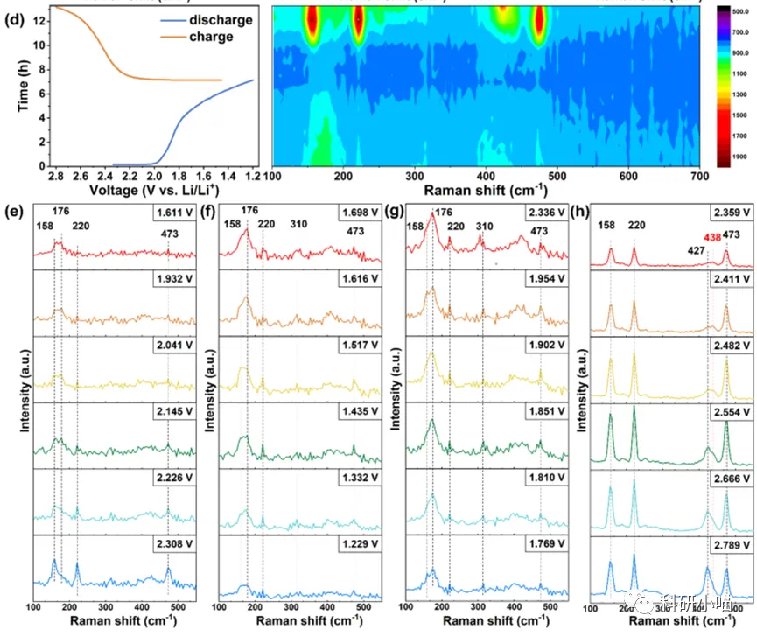
我需要【原位Raman实验中的充放电曲线和对应的Raman强度分布变化。以及(e-h)原位测试中，正极在不同充放电的代表性电压时的Raman光谱】

材料稳定

- 电极测试原位前是否需要活化，如果需要请提供活化条件
不需要
- 如果是采用i-t测试 确认是按照恒压不同时间采点还是变压不同电压间隔采点
0.1V
- 附录类似材料原位Raman数据的参考文献，可单独发群里；如果没有相关参考文献提供的，只要峰位出现变化（含微弱变化），就认为本次测试成功了。
https://doi.org/10.1002/anie.202302363
- 如果是因为隐瞒样品信息或者自己知道本材料的注意点未列出的，概不负责的哦，望理解。

We've tried both Pd/TiO2 nanoparticles on hydrophobic porous carbon paper and Co3O4 nanoparticles on hydrophobic porous carbon paper in a flow cell with 0.1 M K2SO4 + 200 ppm H2O2 and did not observe any meaningful NO3 (~0.1% FE at 15 mA).

唯一的缺陷是使用碳材料作为基底，碳材料在高的氧化电压下会发生严重的电化学氧化。在双氧水存在的情况下，碳材料会被更加剧烈的氧化。这会导致电流的损失以及法拉第效率的损失。
The main limitation appears to stem from using carbon-based substrates. Carbon materials undergo substantial electrochemical oxidation at higher oxidative potentials, and this degradation is significantly accelerated by the presence of hydrogen peroxide. Such oxidation can lead to considerable losses in both current and Faradaic Efficiency.

We also see no NO2- in our IC data whatsoever.

在碳材料存在的情况下，是不会生成NO2-的。因为NO2-的来源是NO和NO2，这两种反应物在碳材料存在的情况下，不会被氧化到NO2-。
It is likely that NO₂⁻ formation is inhibited in the presence of carbon substrates, as NO and NO₂, the typical precursors to NO₂⁻, are unlikely to be oxidized to NO₂⁻ under these conditions. The problem still lies with the carbon material.

We are flowing N2 at our anode at 20 sccm and the electrolyte is flowing at 15 mL min^-1. Our cathode reaction is just a porous carbon paper that is doing ORR to H2O2 to replenish H2O2 lost in the reaction with O2 flowing to our cathode at 20 sccm. Can you identify potentially what is going wrong for us in this system? I would think that even if the reactor design was just slightly worse we would still observe larger amounts of NO3.

电解液的流速建议控制在5-20 mL/h(10.1021/acscatal.4c07033 and 10.1126/science.aay1844)，双氧水的浓度始终保持在200ppm的情况下，无需使用这么大的流速，会降低双氧水的利用效率。

事实上，相比于其他电化学反应，氮气的活化是不容易的，如果你发现氮气可以活化，那么会有很多优化的空间，我在此有一些建议。
      - 缩短阴极和阳极直接的距离，使用膜电极将阴极和阳极紧紧贴在一起，中间使用玻璃纤维或者其他东西分隔。这样会大大提高界面局部的双氧水浓度(10.1016/j.joule.2023.06.022.)和双氧水利用率。
      - 如果你使用阴极产生的双氧水作为氧源，保证阴极的面积是阳极的四倍大。
      - 绝对不要使用容易被氧化的材料作为阳极。建议使用钛片或者其他稳定的基底。

根据你提供的细节，我只能给出这些意见，因为我没有看到反应器以及更多的细节。
祝你实验顺利，如果有其他问题，欢迎问我

Currently, we are introducing nitrogen gas at the anode at a flow rate of 20 sccm and circulating electrolyte at 15 mL/min. At the cathode, porous carbon paper facilitates the oxygen reduction reaction (ORR) to generate H₂O₂, with oxygen gas supplied at 20 sccm to maintain H₂O₂ levels. Could you help identify potential issues with our current setup? Even with suboptimal reactor design, we anticipated observing higher NO₃⁻ concentrations.
Here are some gentle recommendations that might help:
- Consider reducing the electrolyte flow rate to between 5-20 mL/h (suggested by previous studies: DOI: 10.1021/acscatal.4c07033 and 10.1126/science.aay1844). With a stable H₂O₂ concentration of 200 ppm, a lower flow rate may enhance H₂O₂ utilization efficiency.
- Nitrogen activation via electrochemical methods is inherently challenging. However, identifying active nitrogen conversion pathways could present significant optimization opportunities. To enhance your current setup:
  - Shorten the distance between the anode and cathode. Employing a membrane electrode assembly (MEA), separated by materials such as glass fiber, could significantly increase local H₂O₂ concentration and utilization (reference: DOI: 10.1016/j.joule.2023.06.022).
  - If you're using cathode-generated H₂O₂ as the oxygen source, ensure the cathode surface area is approximately four times larger than the anode area.
  - Avoid using oxidizable materials for the anode substrate. Stable alternatives, such as titanium plates, would offer greater durability and prevent efficiency losses.
Given the details provided, these suggestions represent my best recommendations without having a detailed view of your reactor setup. I wish you great success with your experiments and am happy to discuss further if needed.

